RATS – a process drama based on The Pied Piper of Hamelin
Original written by Lyn Shillingford, adapted by Viv Aitken

Dramatic ‘hook’

Set up scene in a formal space – aisle down the middle.

Could use church music to set the scene.
Use a Student in role as the mayor figure (dressed in a tattered suit jacket).
Ask rest of group to watch and offer feedback (2 stage)
Direct the student in role to enter and walk up the aisle with stooped and sad body language. Mime the lighting of a candle, then freeze.
Teacher do live voice over “Look at him now – a broken man. All he tried to do was save his city and it came to this. You’d never believe he was once our leader. What was it brought him so low?
Ask rest of group to describe what they saw and heard then interpret. What could be going on here?
We are going to find out through our drama

Overheard conversations
Hand out copies of extracts from the ‘Pied Piper’ poem.
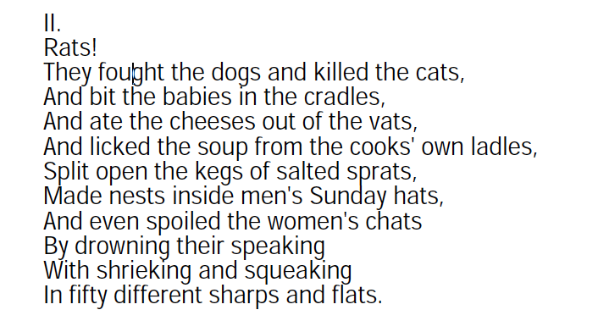

Students work in pairs. Select an incident from this verse and retell it as a story told to a partner in evening as the street lamps are being lit.
Then add a frozen image to start and finish their story.
These are shared back - brought to life by teacher in role as the lamplighter passing through the streets. As the lamplighter ‘lights’ each lamp, the scene comes to life.

Rat chorus
Written exercise – circle pens and paper for all.
Teacher calls out 5-6 sentence starters about rats.
Students complete sentences – pass on to new writer for next prompt.
“Rats smell like…”
“Their tails remind me of….”
“You know a rats is nearby because…”
“The worst thing about rats is….”
“Rats look like…”
At the end select one line from the paper in front of you to say.
Experiment with voice, tone, volume
Form a group and combine lines to creative movement chorus

Role on wall / Conscience alley
Storyteller voice: “So the people of the town had a problem. And no one could think of how to solve it. The mayor and the council gathered to discuss the issue. And suddenly, in walked a stranger…”

Draw an outline of a person on a large piece of paper (could be drawn around a person’s body)
Ask students to write inside the outline with words to describe the stranger as you read the next verse

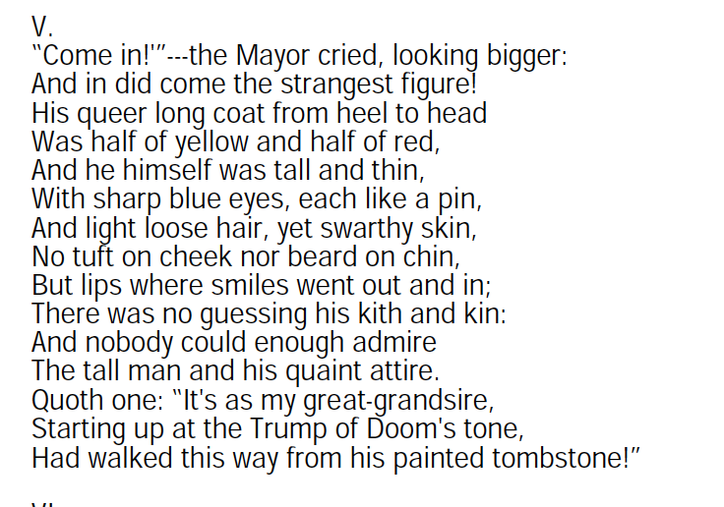

Conscience alley

Ask students to stand around the room and imagine themselves as the townspeople in the market place.

Teacher puts on something to signify the piper (yellow and red scarf?) and moves through the people,

As the piper passes by, the people of the town speak their responses to him
Add to role on wall what people think of him – write around the outside of the outline. Discuss any contradictions. How do people respond to strangers?

Making of the bargain
Teacher reads the next part of the poem:

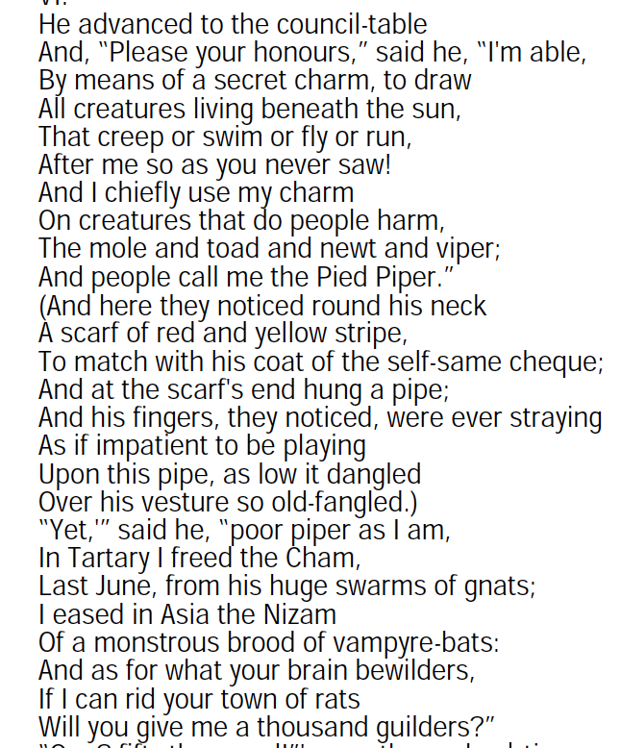

Students in role in four committees (students decide what they will be). T in role tells committees that the mayor has made a snap decision to hire a rodent control contractor which will cost a total of 1000 guilders. The money has to come from their budgets – told to prioritize future spending – reminded there is an election next month so we can’t afford to lose votes. TENSION: remind students that they are all passionate about what they do – don’t want to see any cuts to their budgets and are looking for reasons to argue that the other committees should cut back. Allow time for each group to prepare their arguments, then come together for a debate between the different groups.

Improvisation interrupted with the sound of pipe music
pipe music (could be live or recorded)

Contrasting Still images
Start with a whole group still image / tableau to show the town in celebration at the loss of the rats – piper in centre
Create 2nd image with piper before rats were cleared (based on the initial reaction of the townspeople).
Over count of 8 shift from before to after.

Bargain Broken
Back in council chamber. Students back in role as committee members. T in role as deputy mayor delivering speech [See separate notes] that puts pressure on councillors not to pay – try to gain consensus. If not, say that you’ve decided anyway. Teacher comes out of role, picks up the piper’s yellow and red scarves and speaks: ‘and then the piper entered and spoke “If you please, my 1000 guilders’. What did each councillor say? Students stand one at a time to give their responses…. Thought tap from frozen image.

Moment of significance
Students work solo. Teacher uses the storyteller voice:

“And so the council members all returned home after the meeting. It has been a long and difficult day. As you arrive at your front the door you can hear the sounds of your family members celebrating inside. The door bursts open and your youngest child rushes to meet them: “the rats have gone!” she crys and with tears in their eyes she tells you how the piper is now their hero. She runs back inside and you, council member, tired and weary, stoop to remove your shoes at the door step before going in to join your family.

As you bend down to remove your shoes, you reflect on what you will say to your daughter. How will you explain how you have treated the piper? Students are invited to speak their thoughts aloud one at a time.

Circle to Reflect

Discuss with group what emerged from the last few activities. Does this happen in real life too?

Forum Theatre
Ask two students to take the role of Mayor and Piper
Using the poem below, get the rest of the class to give suggestions on how to play this scene. Keep playing and replaying it with changes until everyone thinks it looks and sounds effective:

The piper’s response
Teacher reads next part of poem

Soundscape

musical instruments

Divide class in two. Introduce a simple musical motif of 4-5 notes (if using melody, use the pentatonic scale) Ask the two groups to create two versions of piper’s tune – one group to work on the joyous sounds heard by the children and the other creating the sounds of horror felt by the parents.
Give the groups time to work on the soundscape. A range of music education practices can be used here.
The two soundscapes are played, finishing with the parent’s version.

Teacher asks the student who began the drama to stand again and put on the tattered jacket. Then speaks these words to close the drama:

“And that is the sound the Mayor still hears every time he enters the church to light candles for the lost children…”

Out of role reflection

Which different roles did we take on during the drama?
Who did you see using the techniques and elements of drama effectively?
How was it working in this way – what was tricky?
What did we learn from this experience?
Are there messages we can take from this story into our own lives?

