Mantle of the Expert
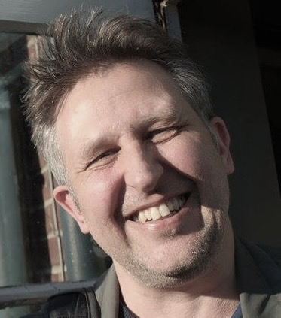
Workshop tour July - August 2020
with Tim Taylor (UK)
author of A Beginner’s Guide to Mantle of the Expert

  - Imaginative inquiry across the New Zealand curriculum

Mantle of the Expert is a teaching approach developed from the work of celebrated educator Prof. Dorothy Heathcote. It combines drama, inquiry and the positioning of participants as ‘experts’ in fictional contexts to produce meaningful, engaging, creative, authentic cross-curricular learning experiences. Participants learn collaboratively, build empathy, think critically and explore multiple points of view. Ideally suited to the NZ curriculum, Mantle of the Expert is listed as an ‘effective pedagogy’ on the TKI website. These one-day workshops will be tailored to your needs: whether you’re a beginner looking for first ideas or a more experienced practitioner keen to deepen your skills and knowledge, you will leave inspired with new things to try in your classroom.

Workshops will run 8.30am – 2.30pm
Lunch is included

Northland – Otaika valley school: Weds 22 July
Auckland – Bayswater school: Fri 24July
Hamilton – Knighton Normal School: Mon 27 July
Hawkes Bay – Hastings Intermediate: Wed 29 July
Wellington – Island Bay School: Fri 31 July
Christchurch – Waitākiri School: Mon 3 August

ENROL HERE
https://tiny.cc/7bw3gz

“Using drama kids develop more empathy ... It’s that empathy I’ve really come to appreciate.”
RD – Primary school teacher

“Co-construction, student voice and the acknowledgement of cultural capital and prior knowledge. This is so key for our students.”
KW - High school teacher

“The power sharing aspect is huge. It allows children to go down pathways as experts – it’s rare for children to have so much power.”
GG – Deputy Principal

“This unique pedagogy not only engages students but achieves academic results.”
SB – Masters Graduate

Cost: $150 per person
+ GST = $172.50
Limited places available

